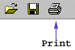
M&IS 24053: Computer Applications
Summer 2003 - Summer I

Prof. Douglas Druckenmiller  ddrucken@kent.edu  College of Business A417  Phone: 330-676-0320 | Prof. David Zhu  xuzhu@kent.edu  College of Business A402  Phone: 330-672-1164
Section 010  Monday - Thursday 2:15pm - 4:10pm  BSA 217 | Section 011  Monday - Thursday 2:15pm - 4:10pm  BSA 108

M&IS 24053: Computer Applications
Course Theme
Solving information related problems using computers, networks, software and data.


M&IS 24053: Computer Applications
Course Objectives
The fundamental objective is for you to develop an appreciation for the contribution that computers and software can make to your life as a student and as a professional. It is expected that during this term you will develop competency in the operation of the hardware and software to which you are exposed. It is further expected that as you master the course material your confidence in your ability will increase.A secondary objective is for this to be an enjoyable and fun learning experience.


M&IS 24053: Computer Applications
Textbook and Other Materials
The course's text book is Computers and Information Systems, Steinberg, Geoffrey, Paperclip Productions
Most of the text's material will be covered. Use the course's weekly schedule as a guide so that you read the appropriate chapters before that material is covered in class. You should read the material before coming to class so that you are ready to participate in the class discussion.

Class Slide Presentations
Copies of the instructor's classroom slide presentations are included with the textbook. You will find these copies very handy when you take class notes. The textbook has exact images of most of the slides used by the instructor. Take your notes directly on the copies. It will make note taking easier and more accurate. You will find it easier to study for quizzes too.

Class Notes
The textbook provides pages for your class note taking. You are encouraged to use these pages so that your notes, the text material and the classroom slides are kept together. This too will help you master the material and prepare for quizzes.

Floppy Disk
You should use the floppy disk which is packaged with the book. Although not required, you may wish to purchase a 3.5" floppy disk to use for backing up your homework.

M&IS 24053: Computer Applications
Orion
Many of your course activities are interactive and involve using the Orion server. Quizzes and homework are administered and graded by Orion.

Follow these steps to log on to Orion:
- Start a web browser. You must use Internet Explorer. (Some ORION functions do not operate in Netscape due to security considerations.)
- Go to this web address: http://orion.kent.edu
- Select this option:
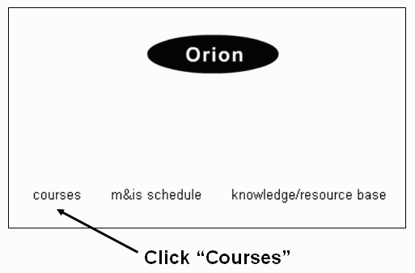
- Enter your log on information:
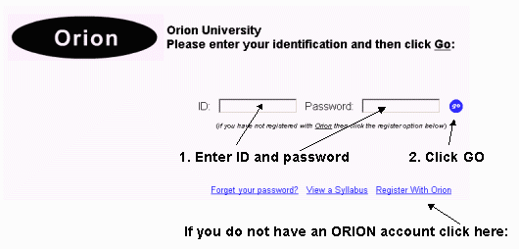

M&IS 24053: Computer Applications
Homework
There are 11 regular assignments. Each assignment is worth 2 or 3 points toward your total semester grade. To view specifics about assignments use your ID and password to log on to Orion and use the option shown below:
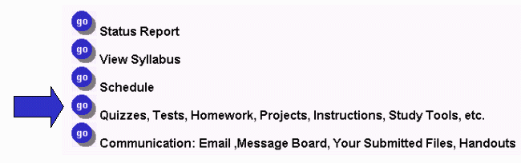
• All regular assignments are graded automatically by the Orion System.
• Each regular assignment must be completed by the due date.
• You may submit any regular assignment three times until the due date.
• The grade on record at the due date is your grade.

Schedule
The schedule (available from your Orion menu - see above) shows you the homework and extra credit due dates.

Submitting Regular Assignments
You will complete most of your regular assignments using a disk such as the one included with the text. To submit regular assignments use the "Quizzes, tests ..." option from your personal Orion System menu (see above).

Grade Status
Each time a regular assignment is graded a fresh copy of your grade status report will be put on the Internet for you to access. See menu above for access to status report.

M&IS 24053: Computer Applications
Extra Credit
There are 5 extra-credit assignments and 2 extra-credit surveys. All together you may earn up to six points of extra credit. To view specifics about assignments use your ID and password to log on to Orion and use the option shown below:
• Each extra-credit assignment and survey is graded automatically by the Orion System.
• Each must be completed by the due date.
• Extra-credit assignment and survey may be submitted only once.
• Each extra-credit assignment and survey is worth up to 1 point added to your final course average.

Schedule
The schedule (available from your Orion menu - see above) shows you the homework and extra credit due dates.

Submitting Extra-Credit Assignments
You will complete most of your extra-credit assignments using a disk such as the one included with the text. To submit extra-credit assignments use the "Quizzes, tests ..." option from your personal Orion System menu (see above).

Grade Status
Each time an extra-credit assignment is graded a fresh copy of your grade status report will be put on the Internet for you to access. See menu above for access to status report.

M&IS 24053: Computer Applications
Quizzes
- There are 5 short objective quizzes through the semester. The schedule (available from your Orion menu - see illustration below) shows you the quiz due dates.
- Each quiz score is computed as a percent correct. (a perfect score is 100% )
- Each quiz is worth 15 points toward your total semester grade. If you score 100% on a quiz then you earn all 15 points. If you score less than 100% the points earned are adjusted accordingly.
- Each quiz is curved up to an average of 75% if necessary. Averages are not curved down! This means that if the class average is 72 then 3 points are added to eveyone's quiz score to bring the average up to 75.
- Each quiz can be taken from any computer that has Internet Explorer 5.1 or greater.
- Each quiz is a self-contained unit. That means that the quizzes are not comprehensive. Each quiz contains material covered in class during the week prior to the beginning of the quiz period.
- There is no final exam. The 5th quiz is also non-comprehensize and is taken during the final Thursday.
- Quizzes are open notes and you are permitted to use other software while taking a quiz. You are not permitted to discuss anything with anyone while taking a quiz - violations are grounds for receiving a grade of 0 for the quiz in progress.

Taking a Quiz
You may not begin any quiz until you demonstrate your understanding of the syllabus. You must do this by completing the Syllabus Contract
Once you have successfully completed the Syllabus Contract you begin a quiz this way:
- Log on to Orion and select the "Quizzes, tests, ..." option (see above).
- Select the quiz you want to take.

Study Tools
Study tools are available for each quiz. To view a study guide or try a practice quiz: Log on to Orion and select the "Quizzes, tests, ..." option (see above).

Viewing Results
Once a quiz period has ended you may view your quiz (all questions and answers) by locating the quiz in your status report.

M&IS 24053: Computer Applications
Syllabus Contract
This syllabus is a contract between you and the instructor. Your responsibilities are described in this document. Before you are permitted to attempt any of the course quizzes you must demonstrate that you understand the contract (syllabus) by earning a perfect score (100%) on a syllabus survey. Check the course schedule for the survey dates.
You are permitted to attempt the Syllabus Contract Survey as often as you like until you reach 100%. You may attempt the Survey from any Internet connected computer.
It is strongly suggested that you print this syllabus (use the Print All option) and use it while completing the survey.
To find the Syllabus Contract select the Orion menu option indicated below:

M&IS 24053: Computer Applications
Your Grade

Rules
- You semester grade is the weighted average of the 5 quizzes + 11 homework assignments.
- Each quiz and homework is to be completed on time by the due date. You receive no credit for quizzes or homeworks incomplete after the due date.
- Up to 5 points of extra credit may be added to your quiz and homework average. The 5 extra credit assignments have due dates as well.
- The Kent State grading scale is used:
90+ | 80-89 | 70-79 | 60-69 | 0-59
A | B | C | D | E
Grades are rounded, so 89.5 becomes an A.

Grading Example
Your grade is based on 5 quizzes (worth 15 points each) and 11 homeworks (worth 2 or 3 points each) and 5 extra credit assignments (worth 1 point each).
Here is an example of 5 quiz grades and 11 homework grades:
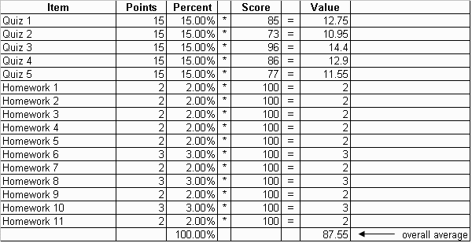
87.55 points would be a B grade. This grading scale is used:
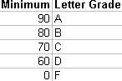

How extra credit works
If this student earned 2 extra credit points then a total of 89.55 points (87.55 + 2) was earned. The letter grade becomes A because grades are rounded (89.55 rounded to 90).

Important Notes:
- Grades are rounded (see above)
- On each quiz the final average for the class will always be at least 75. If the average is below 75 when all students have completed the quiz then the average will be increased to 75. If the average is at least 75 when all students have completed the quiz then the average is not changed. Quiz averages are never rounded down! Here is an example:
Suppose the class average for Quiz 3 is 70. To curve up to 75 each student is given 5 extra points for their individual Quiz 3 score. So if you received a Quiz 3 score of 72 then your score becomes 77 after the curve is applied.
- Final semester averages are not curved.

M&IS 24053: Computer Applications
Daily Class Schedule and Reading Assignments
• The daily schedule indicates the topics covered during each class session.
• You are expected to complete the reading assignments (pages shown in ()) prior to each class meeting.
• The Quiz column indicates what quiz covers the material shown to the left.
Week | Content | Quizzes
1 | 6/9 M: Introduction  Data and Information (1.1-1.15)  6/10 T: Windows (3.1-3.17)  6/11 W: Hardware (4.1-4.6)  Software (4.6-4.11)  Excel - Introduction: | 1
1 | 6/12 Th: Excel - Functions & Formulas (6.1-6.13)  Excel - Other Kinds of Data(6.18-6.23)  Excel - Data Menu (6.27-6.40)  6/16 M: Information Systems (2.1-2.7)  6/17 T: Email (9.25-9.27) | 2
2 |  | 2
2 | 6/18 W: Communications(9.1-9.25)  6/19 Th: Graphics/PowerPoint(7.1-7.15 & Appx A)  6/23 M: Excel - Cell Addressing 6.45-6.58)  Excel - Logic(6.64-6.69)  6/24 T: Internet & HTML (10.1-10.19) | 3
3 |  | 3
3 | 6/25 W: Excel - Linking Spreadsheets(6.74)  Excel - Merging Tables(6.75-6.78)  6/26 Th: No Class  6/30 M: Excel - Rel Between Records (6.78-6.80)  Excel - Charts (6.84-6.89)  Excel - Statistics (6.89-6.90) | 4
4 |  | 4
4 | 7/1 T: Database - Introduction, Single Table Ops (8.1-8.10)  Database - Database Theory (8.34-8.36)  7/2 W: Database - Creating a Database(8.20 - 8.30)  Database - Multi Table Joins (8.12-8.14)  7/3 Th: No Class – Happy 4th of July  7/7-10 M-Th: Quizes/Homework | 5
5 |  | 5

M&IS 24053: Computer Applications
How to Reach Me
We will be available to help you during certain hours each week.
We can be found in the 4th floor annex of the Business Administration building.
Prof. Druckenmiller is in office A409.
Prof. Zhu is in office A402.
We will be available in our offices during the hours shown in the following table:

Monday / Thursday | 1:45-2:15pm
Monday / Thursday | 4:10-4:30pm
Other hours by appointment only
We will be available for help on assignments, class content, and individual concerns during those hours.
Due to FERPA mandates, we cannot discuss your grades by email, by phone, or by fax. If you need to discuss grades, please see your instructor in his office.

M&IS 24053: Computer Applications
Rules
In order to be fair to all students the following rules are enforced:

Review of a Quiz Grade
You may ask the instructor to review any specific questions on any quiz or homework assignment. You must make the request not more than one week after the quiz or assignment due date has passed. Requests after that deadline will be automatically rejected.

Computer Virus
WARNING!!! If you submit an assignment with a computer virus then you fail the course. No exceptions! It is your responsibility to ensure that your work is clean.

Excused lateness
The following are the only accepted excuses for late homework or permission to take a quiz late:
  - sickness with medical note
  - athletic event - with coach's note
  - religious observation
  - military responsibility with documentation
  - death in family with documentation

Lecture
You are expected to respect the other students! This means never ridicule anyone for asking a question. There is no such thing as a stupid question but it is stupid not to ask questions! Laughing at or ridiculing another student is grounds for dismissal from this course with a grade of F.

Cheating
Cheating is grounds for automatic failure in the course so don't do it! Cheating includes, but is not limited to, copying from another student during an exam, submitting the same homework as another student, and illegally copying (really stealing) software.Any voliation is grounds for dismissal from this course with a grade of F.

Respect
You are expected to act in a proper fashion at all times during the semester. Being respectful of other students and the instructor is essential. Behavior otherwise will not be tolerated and is ground for dismissal from the course at any time during the semester. Dismissal results in a grade of F.

Cell Phones and Pagers
Use of a cell phone or pager during class is grounds for removal from the class. Use of such equipment is rude and disrespectful towards the instructor and other students (see respect above). Use of a cell phone or pager during class is ground for dismissal from this course with a grade of F.

M&IS 24053: Computer Applications
Etc.

Lecture
No early mass exodus from the lecture hall. If you plan to leave early then don't come to class. There are other students who want to be in class and it is not fair to disrupt them by the noise and disturbance of early departures.

Attendance
Attendance is not mandatory but it is strongly recommended. You are responsible for all material presented. It is not reasonable for you to ask for special consideration claiming that you miss material because you were not in class.

Students with Disabilities
In accordance with University policy, if you have a documented disability and require accomodations to obtain equal access in this course, please contact the instructor at the beginning of the semester or when given an assignment for which accomodation is required. Students with disabilities must verify their eligibility through Kelly Kulick in the Office of Student Disability Services (244-3287).

